Microservices with Spring Boot 3 and Spring Cloud

1) Creating Microservices for account and loan
In this hands on exercises, we will create two microservices for a bank. One microservice for handing accounts and one for handling loans. Each microservice will be a specific independent Spring Restful Webservice maven project having it's own pom.xml. The only difference is that, instead of having both account and loan as a single application, it is split into two different applications. These webservices will be a simple service without any backend connectivity.

Code:
AccountController.java
package com.cognizant.account;
import org.springframework.web.bind.annotation.*;
@RestController
@RequestMapping("/accounts")
public class AccountController {
@GetMapping("/{number}")
public Account getAccountDetails(@PathVariable String number) {
return new Account(number, "savings", 234343);
}
static class Account {
private String number;
private String type;
private double balance;
public Account(String number, String type, double balance) {
this.number = number;
this.type = type;
this.balance = balance;
}
public String getNumber() { return number; }
public String getType() { return type; }
public double getBalance() { return balance; }
}
}

OUTPUT:
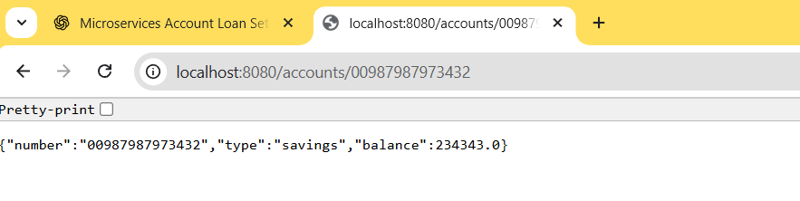

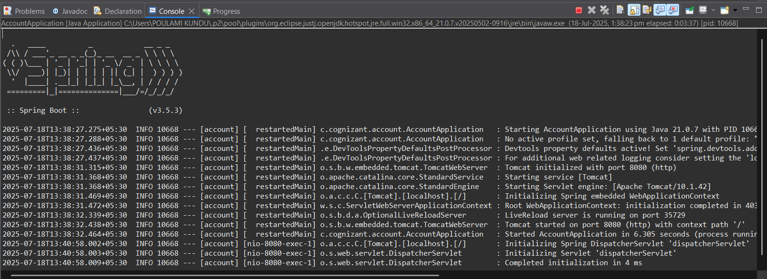

LoanController.java
package com.cognizant.loan;
import org.springframework.web.bind.annotation.*;
@RestController
@RequestMapping("/loans")
public class LoanController {
@GetMapping("/{number}")
public Loan getLoanDetails(@PathVariable String number) {
return new Loan(number, "car", 400000, 3258, 18);
}
static class Loan {
private String number;
private String type;
private double loan;
private double emi;
private int tenure;
public Loan(String number, String type, double loan, double emi, int tenure) {
this.number = number;
this.type = type;
this.loan = loan;
this.emi = emi;
this.tenure = tenure;
}
public String getNumber() { return number; }
public String getType() { return type; }
public double getLoan() { return loan; }
public double getEmi() { return emi; }
public int getTenure() { return tenure; }
}
}

OUTPUT:
